- Linear Regression – Batch Gradient Descent
clc;
table1 = xlsread('D:\CMS\Sem3-1\Neural Networkand Fuzzy Logic\data.xlsx');
% X is the matrix containing feature vectors for all instances
X = ones(size(table1,1),1);
X = [X table1(:,1:2)];
% Inputs normalization
X(:,2) = (X(:,2)-mean(X(:,2)))/std(X(:,2));
X(:,3) = (X(:,3)-mean(X(:,3)))/std(X(:,3));
%Target outputs (normalized)
y = (table1(:,3)-mean(table1(:,3)))/std(table1(:,3));
clear table1
w = [0 0 0]; %Initial weights
alpha = 0.001; %Learning rate
k = input('Enter number of iterations: '); %In this case, 40
J = zeros(k+1,1); %Array to store cost for each iteration
W = zeros(k+1,2); %Array to store weigthts for each iteration
J(1) = evaluatecostfunction(X,y,w); %Calculating initial cost
W(1,1) = w(1);
W(1,2) = w(2);
for i=1:k
h = (X*w')-y; %Hypothesis calculation
for j = 1:3
w(j) = w(j) - alpha*(h'*X(:,j)); %Weight updates
end
J(i+1) = evaluatecostfunction(X,y,w); %Calculating cost
W(i+1,1) = w(2);
W(i+1,2) = w(3);
end
plot(0:k,J) %Plotting cost vs number of iterations
clear i j h
w1 = 0.4:-0.001:-0.2;
w2 = 1:-0.005:-0.2;
J1 = zeros(length(w1),length(w2));
for i=1:length(w1)
for j=1:length(w2)
J1(i,j) = evaluatecostfunction(X,y,[0 w1(i) w2(j)]); %Calculating cost
end
end
%Plotting cost function vs weights
figure; plot3(W(:,2),W(:,1),J,'color','r'); grid ON; %Batch gradient descent – Cost vs w1 and w2
figure; contour(w2,w1,J1); hold on; plot(W(:,2),W(:,1),'color','r') %Contour plot
clear i j
%Function to evaluate cost function for linear regression
function J = evaluatecostfunction(X,y,w)
J = 0;
for i=1:size(X,1)
J = J + ((w*X(i,:)')-y(i))^2;
end
J = 0.5*J;
End
Number of iterations: 40
Final Weight: [1.1306e-15 0.0781 0.3606]
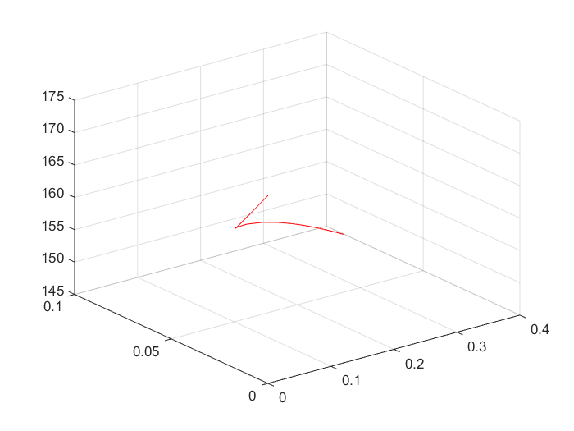
2. Linear Regression – Stochastic Gradient Descent
table1 = xlsread('D:\CMS\Sem3-1\Neural Networkand Fuzzy Logic\data.xlsx');
% X is the matrix containing feature vectors for all instances
X = ones(size(table1,1),1);
X = [X table1(:,1:2)];
% Inputs normalization
X(:,2) = (X(:,2)-mean(X(:,2)))/std(X(:,2));
X(:,3) = (X(:,3)-mean(X(:,3)))/std(X(:,3));
%Target outputs
y = (table1(:,3)-mean(table1(:,3)))/std(table1(:,3));
clear table1
w = [0 0 0]; %Initial weights
alpha = 0.001; %Learning rate
k = input('Enter number of iterations: '); %In this case, 100
m = 50; %Number of training instances taken in each iteration
J = zeros(k*m+1,1); %Array to store cost for each iteration
W = zeros(k*m+1,3); %Array to store weigthts for each iteration
J(1) = evaluatecostfunction(X,y,w); %Calculating initial cost
W(1,1) = w(1);
W(1,2) = w(2);
W(1,3) = w(3);
for i=1:k
a = randperm(size(X,1),m); %Shuffling the data for each iteration
for j=1:m
h = (X(a(j),:)*w')-y(a(j)); %Hypothesis calculation
for b = 1:3
w(b) = w(b) - alpha*(h*X(a(j),b)); %Weight updates
W((i-1)*m+j+1,b) = w(b); %Storing weights in array
end
J((i-1)*m+j+1) = evaluatecostfunction(X,y,w); %Calculating cost
end
end
plot(0:k*m,J) %Plotting cost vs number of iterations
clear i j a b h
w1 = 0.4:-0.001:-0.2;
w2 = 0.8:-0.005:-0.2;
J1 = zeros(length(w1),length(w2));
for i=1:length(w1)
for j=1:length(w2)
J1(i,j) = evaluatecostfunction(X,y,[0 w1(i) w2(j)]);
end
end
%Stochastic gradient descent - cost vs w1 and w2
figure; plot3(W(:,2),W(:,1),J,'color','r'); grid ON; %3D plot
figure; contour(w2,w1,J1); hold on; plot(W(:,3),W(:,2),'color','r') %Contour plot
clear i j
%Function to evaluate cost function for linear regression
function J = evaluatecostfunction(X,y,w)
J = 0;
for i=1:size(X,1)
J = J + ((w*X(i,:)')-y(i))^2;
end
J = 0.5*J;
end
Number of iterations: 40
Final Weight: [0.0126 0.0924 0.3177]
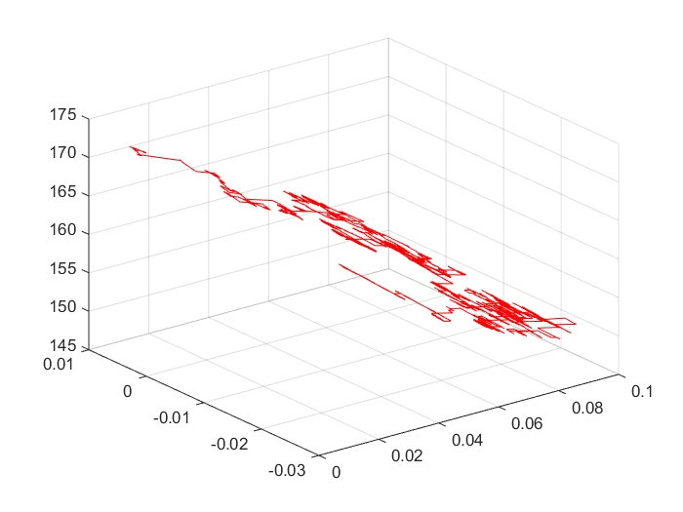
3. Ridge Regression
Batch Gradient
table1 = xlsread('D:\CMS\Sem3-1\Neural Networkand Fuzzy Logic\data.xlsx');
% X is the matrix containing feature vectors for all instances
X = ones(size(table1,1),1);
X = [X table1(:,1:2)];
% Inputs normalization
X(:,2) = (X(:,2)-mean(X(:,2)))/std(X(:,2));
X(:,3) = (X(:,3)-mean(X(:,3)))/std(X(:,3));
%Target outputs
y = (table1(:,3)-mean(table1(:,3)))/std(table1(:,3));
clear table1
w = [0 0 0]; %Initial weights
alpha = 0.001; %Learning rate
lambda = 0.4; %Regularisation parameter
k = input('Enter number of iterations: '); %In this case, 25
J = zeros(k+1,1); %Array to store cost for each iteration
W = zeros(k+1,2); %Array to store weigthts for each iteration
J(1) = evaluatecostfunction(X,y,w,lambda); %Calculating initial cost
W(1,1) = w(1);
W(1,2) = w(2);
for i=1:k
h = (X*w')-y; %Hypothesis calculation
for j=1:3
w(j) = w(j) - alpha*(h'*X(:,j))-alpha*lambda*w(j); %Weight updates
end
J(i+1) = evaluatecostfunction(X,y,w,lambda); %Calculating cost
W(i+1,1) = w(2);
W(i+1,2) = w(3);
end
plot(0:k,J) %Plotting cost vs number of iterations
clear i j h
w1 = 0.4:-0.001:-0.2;
w2 = 0.8:-0.005:-0.2;
J1 = zeros(length(w1),length(w2));
for i=1:length(w1)
for j=1:length(w2)
J1(i,j) = evaluatecostfunction(X,y,[0 w1(i) w2(j)],lambda);
end
end
%Plotting weights vs cost function
figure; plot3(W(:,2),W(:,1),J,'color','r'); grid ON; %Batch gradient descent – Cost vs w1 and w2
figure; contour(w2,w1,J1); hold on; plot(W(:,2),W(:,1),'color','r') %Contour plot
clear i j
%Function to evaluate cost function for ridge regression
function J = evaluatecostfunction(X,y,w,l)
J = 0;
for i=1:size(X,1)
J = J + ((w*X(i,:)')-y(i))^2;
end
J = J+(l*sum(w.^2));
J = 0.5*J;
end
Number of iterations:40
Final Weight: [1.1285e-15 0.0781 0.3601]
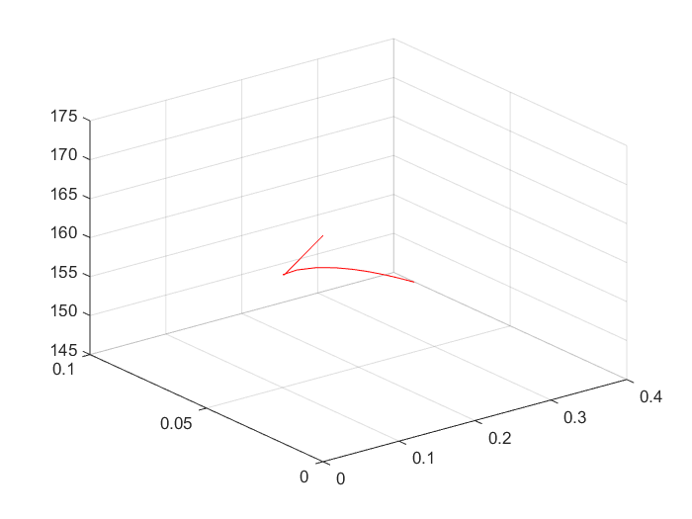
Stochastic Gradient Descent
table1 = xlsread('D:\CMS\Sem3-1\Neural Networkand Fuzzy Logic\data.xlsx');
% X is the matrix containing feature vectors for all instances
X = ones(size(table1,1),1);
X = [X table1(:,1:2)];
% Inputs normalization
X(:,2) = (X(:,2)-mean(X(:,2)))/std(X(:,2));
X(:,3) = (X(:,3)-mean(X(:,3)))/std(X(:,3));
%Target outputs
y = (table1(:,3)-mean(table1(:,3)))/std(table1(:,3));
clear table1
w = [0 0 0]; %Initial weights
alpha = 0.001; %Learning rate
lambda = 0.25; %Regularisation parameter
k = input('Enter number of iterations: '); %In this case, 350
m = 50; %Number of training instances taken in each iteration
J = zeros(k*m+1,1); %Array to store cost for each iteration
W = zeros(k*m+1,3); %Array to store weigthts for each iteration
J(1) = evaluatecostfunction(X,y,w,lambda); %Calculating initial cost
W(1,1) = w(1);
W(1,2) = w(2);
W(1,3) = w(3);
for i=1:k
a = randperm(size(X,1),m); %Shuffling the data for each iteration
for j=1:m
h = (X(a(j),:)*w')-y(a(j)); %Hypothesis calculation
for b=1:3
w(b) = w(b) - alpha*(h'*X(a(j),b))-alpha*lambda*w(b); %Weight updates
W((i-1)*m+j+1,b) = w(b); %Storing weights in array
end
J((i-1)*m+j+1) = evaluatecostfunction(X,y,w,lambda); %Calculating cost
end
end
plot(0:k*m,J) %Plotting cost vs number of iterations
clear i j a b h
w1 = 0.4:-0.001:-0.2;
w2 = 0.8:-0.005:-0.2;
J1 = zeros(length(w1),length(w2));
for i=1:length(w1)
for j=1:length(w2)
J1(i,j) = evaluatecostfunction(X,y,[0 w1(i) w2(j)],lambda);
end
end
%Stochastic gradient descent - cost vs w1 and w2
figure; plot3(W(:,3),W(:,2),J,'color','r'); grid ON; %3D plot
figure; contour(w2,w1,J1); hold on; plot(W(:,3),W(:,2),'color','r') %Contour plot
clear i j
%Function to evaluate cost function for ridge regression
function J = evaluatecostfunction(X,y,w,l)
J = 0;
for i=1:size(X,1)
J = J + ((w*X(i,:)')-y(i))^2;
end
J = J+(l*sum(w.^2));
J = 0.5*J;
end
Number of iterations:40
Final Weight: [-0.0131 0.1000 0.2903]
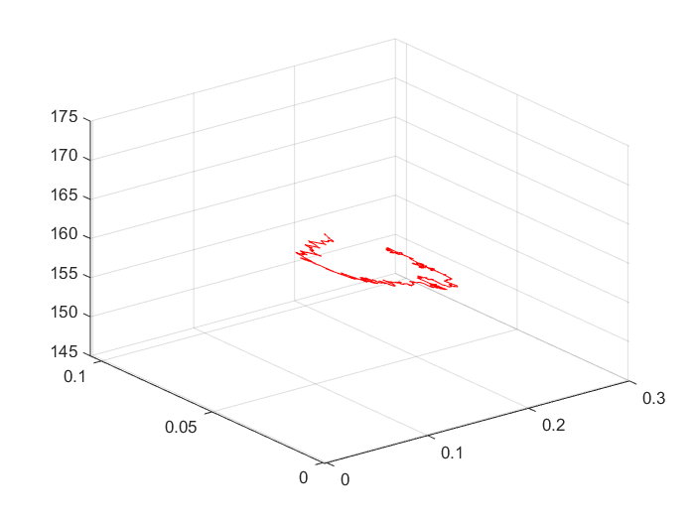
4. Vectorized linear regression
table1 = xlsread('D:\CMS\Sem3-1\Neural Networkand Fuzzy Logic\data.xlsx');
% X is the matrix containing feature vectors for all instances
X = ones(size(table1,1),1);
X = [X table1(:,1:2)];
% Inputs normalization
X(:,2) = (X(:,2)-mean(X(:,2)))/std(X(:,2));
X(:,3) = (X(:,3)-mean(X(:,3)))/std(X(:,3));
%Target outputs
y = (table1(:,3)-mean(table1(:,3)))/std(table1(:,3));
clear table1
w = (X'*X)\X'*y; %Weight evaluation using vectorised linear regression
w_bgd=[1.13e-15;0.0781;0.3606]; %Weights from linear regression - batch gradient descent
w_sgd=[-0.0029;0.0990;0.2951];%Weights from linear regression - stochastic gradient descent
e1 = sqrt(sum((w-w_bgd).^2)); %Error with respect to batch gradient descent
e2 = sqrt(sum((w-w_sgd).^2)); %Error with respect to stochastic gradient descent
Final Weight=[0.0000;0.0781;0.3606]
e1=5.7976e-05
e2=0.0688

5. Least Angle Regression- Batch Gradient Descent
table1 = xlsread('D:\CMS\Sem3-1\Neural Networkand Fuzzy Logic\data.xlsx');
% X is the matrix containing feature vectors for all instances
X = ones(size(table1,1),1);
X = [X table1(:,1:2)];
% Inputs normalization
X(:,2) = (X(:,2)-mean(X(:,2)))/std(X(:,2));
X(:,3) = (X(:,3)-mean(X(:,3)))/std(X(:,3));
%Target outputs
y = (table1(:,3)-mean(table1(:,3)))/std(table1(:,3));
clear table1
w = [0 0 0]; %Initial weights
alpha = 0.001; %Learning rate
lambda = 0.4; %Regularisation parameter
k = input('Enter number of iterations:'); %In this case, 25
J = zeros(k+1,1); %Array to store cost for each iteration
W = zeros(k+1,2); %Array to store weigthts for each iteration
J(1) = evaluatecostfunction(X,y,w,lambda); %Calculating initial cost
W(1,1) = w(1);
W(1,2) = w(2);
for i=1:k
h = (X*w')-y; %Hypothesis calculation
for b=1:3
w(b) = w(b) - alpha*(h'*X(:,b))-0.5*alpha*lambda*sign(w(b)); %Weight updates
end
J(i+1) = evaluatecostfunction(X,y,w,lambda); %Calculating cost
W(i+1,1) = w(2);
W(i+1,2) = w(3);
end
plot(0:k,J) %Plotting cost vs number of iterations
clear b i h
w1 = 0.4:-0.001:-0.2;
w2 = 0.8:-0.005:-0.2;
J1 = zeros(length(w1),length(w2));
for i=1:length(w1)
for j=1:length(w2)
J1(i,j) = evaluatecostfunction(X,y,[0 w1(i) w2(j)],lambda);
end
end
%Plotting weights vs cost function
figure; plot3(W(:,2),W(:,1),J,'color','r'); grid ON; %Batch gradient descent – Cost vs w1 and w2
figure; contour(w2,w1,J1); hold on; plot(W(:,2),W(:,1),'color','r') %Contour plot
clear i j
%Function to evaluate cost function for least angle regression
function J = evaluatecostfunction(X,y,w,l)
J = 0;
for i=1:size(X,1)
J = J + ((w*X(i,:)')-y(i))^2;
end
J = J+(l*sum(abs(w)));
J = 0.5*J;
end
Number of iterations: 40
Final Weight: [-1.2e-4 0.0776 0.3601]
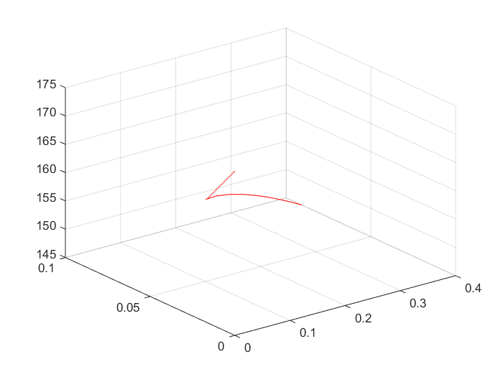
Stochastic Gradient Descent
table1 = xlsread('D:\CMS\Sem3-1\Neural Networkand Fuzzy Logic\data.xlsx');
% X is the matrix containing feature vectors for all instances
X = ones(size(table1,1),1);
X = [X table1(:,1:2)];
% Inputs normalization
X(:,2) = (X(:,2)-mean(X(:,2)))/std(X(:,2));
X(:,3) = (X(:,3)-mean(X(:,3)))/std(X(:,3));
%Target outputs
y = (table1(:,3)-mean(table1(:,3)))/std(table1(:,3));
clear table1
w = [0 0 0]; %Initial weights
alpha = 0.001; %Learning rate
lambda = 0.1; %Regularisation parameter
k = input('Enter number of iterations: '); %In this case, 200
m = 25; %Number of training instances taken in each iteration
J = zeros(k*m+1,1); %Array to store cost for each iteration
W = zeros(k*m+1,3); %Array to store weigthts for each iteration
J(1) = evaluatecostfunction(X,y,w,lambda); %Calculating initial cost
W(1,1) = w(1);
W(1,2) = w(2);
W(1,3) = w(3);
for i=1:k
a = randperm(size(X,1),m); %Shuffling the data for each iteration
for j=1:m
h = (X(a(j),:)*w')-y(a(j)); %Hypothesis calculation
for b = 1:3
w(b) = w(b) - alpha*(h'*X(a(j),b))-0.5*alpha*lambda*sign(w(b)); %Weight updates
W((i-1)*m+j+1,b) = w(b); %Storing weights in array
end
J((i-1)*m+j+1) = evaluatecostfunction(X,y,w,lambda); %Calculating cost
end
end
plot(0:k*m,J) %Plotting cost vs number of iterations
clear i j a b h
w1 = 0.4:-0.001:-0.2;
w2 = 0.8:-0.005:-0.2;
J1 = zeros(length(w1),length(w2));
for i=1:length(w1)
for j=1:length(w2)
J1(i,j) = evaluatecostfunction(X,y,[0 w1(i) w2(j)],lambda);
end
end
%Stochastic gradient descent - cost vs w1 and w2
figure; plot3(W(:,3),W(:,2),J,'color','r'); grid ON; %3D plot
figure; contour(w2,w1,J1); hold on; plot(W(:,3),W(:,2),'color','r') %Contour plot
clear i j
%Function to evaluate cost function for least angle regression
function J = evaluatecostfunction(X,y,w,l)
J = 0;
for i=1:size(X,1)
J = J + ((w*X(i,:)')-y(i))^2;
end
J = J+(l*sum(abs(w)));
J = 0.5*J;
end
Number of iterations:40
Final weight: [0.0070 0.0363 0.1940]
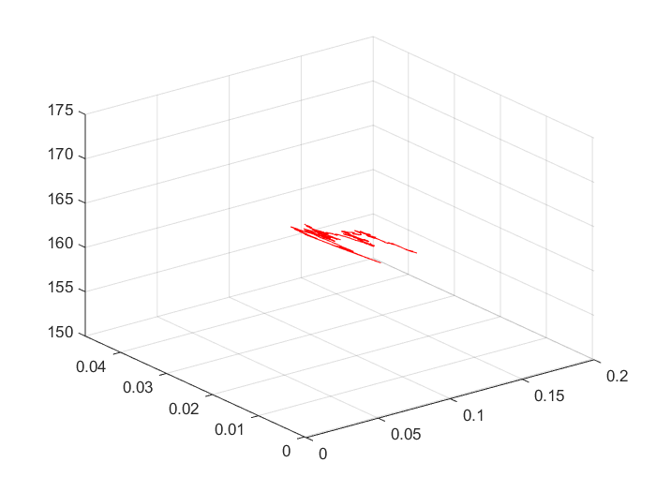
6. K-means Clusttering
X = xlsread('D:\CMS\Sem3-1\Neural Networkand Fuzzy Logic\data2.xlsx');
n = input('Enter number of iterations: '); %In this case, 100
[v, c] = kMeansClustering(X,2,n); %Calling the function for k-means clustering
classColors = zeros(size(X,1), 3); %Array to assign class colors to each data element, (3 for r,g,b)
markerSizes = zeros(size(X,1), 1); %Array to assign marker size to each data element
for row = 1 : size(X,1)
if c(row)==1
% Class 1 = blue
classColors(row,:) = [0, 0, 1];
markerSizes(row) = 20;
else
% Class 2 = red
classColors(row, :) = [1, 0, 0];
markerSizes(row) = 20;
end
end
clear row
%Class vs feature values 1
figure;
scatter(X(:,1),c, markerSizes, classColors);
hold on; scatter(v(:,1),1:2,40,[0 1 0],'LineWidth',2)
%Class vs feature values 2
figure;
scatter(X(:,2),c, markerSizes, classColors);
hold on; scatter(v(:,2),1:2,40,[0 1 0],'LineWidth',2)
%Class vs feature values 3
figure;
scatter(X(:,3),c, markerSizes, classColors);
hold on; scatter(v(:,3),1:2,40,[0 1 0],'LineWidth',2)
%Class vs feature values 4
figure;
scatter(X(:,4),c, markerSizes, classColors);
hold on; scatter(v(:,4),1:2,40,[0 1 0],'LineWidth',2)
%Function to perform k - means Clustering
function [v, c] = kMeansClustering(X,K,n)
[row, col] = size(X);
v = zeros(K,col); %Cluster centres
c = zeros(row,1); %Array to assign clusters to each element in input
u = zeros(K,1); %Array to store number of elements in each cluster
p = randperm(size(X,1),K); %Shuffling data
for i = 1:K
v(i,:) = X(p(i),:); %Assigning K random values to initial centres
end %random cluster centre are alloted
for i = 1:n
d = zeros(row,K); %Array to store distances
for j=1:row
for k = 1:K
%the distance between cluster center and the data point
d(j,k) = sqrt(sum((X(j,:)-v(k,:)).^2));
end
%the cluster to which the data point belongs
c(j) = find(d(j,:)==min(d(j,:)),1);
end
for k=1:K
%Calculating mean of cluster elements to recalculate new cluster centers
u(k) = sum(c(:)==k);
v(k,:) = sum(X(find(c(:)==k),:))/u(k);
end
end
end

7. Logistic regression – Binary classification
X = xlsread('D:\CMS\Sem3-1\Neural Networkand Fuzzy Logic\data3.xlsx');
X(:,1:4) = (X(:,1:4)-mean(X(:,1:4)))./std(X(:,1:4));
%Input normalization
X(:,5) = X(:,5)-1; %Converting classes 1 and 2 to 0 and 1
p = randperm(size(X,1)); %Shuffling data
%Dividing the data into training data (60%) and testing data (40%)
train_data = [ones(0.6*size(X,1),1) X(p(1:0.6*size(X,1)),:)];
test_data = [ones(0.4*size(X,1),1) X(p(0.6*size(X,1)+1:end),:)];
clear p X
w = zeros(1,size(train_data,2)-1); %Weights initialization
alpha = 0.01; %Learning rate
k = 10; %Number of iterations
y = train_data(:,6); %Target classes for training data
for i=1:k
g = logsig(w*(train_data(:,1:5)'))'; %Hypothesis calculation
%Weights update
for j = 1:size(train_data,2)-1
w(j) = w(j)-alpha*sum((y.*(1-g)+(y-1).*g).*train_data(:,j));
end
end
clear i j g y
yp = logsig(w*test_data(:,1:5)')'; %Hypothesis calculation using test data
yp = 1*(yp<0.5); %Class prediction
y_1 = test_data(:,6);
%Target classes for testing data
TN = 0; %True negative
TP = 0; %True positive
FN = 0; %False negative
FP = 0; %False positive
for i = 1:size(yp,1)
switch(yp(i))
case 0
if(yp(i)==y_1(i)) TN = TN+1;
else FN = FN+1;
end
case 1
if (yp(i)==y_1(i)) TP = TP+1;
else FP = FP+1;
end
end
end
ConfusionMatrix = [TN FP; FN TP]; %Calculation of confusion matrix
%Sensitivity - proportion of abnormal episodes that are accurately classified as abnormal
Sensitivity = TP/(TP+FN);
%Specificity - proportion of normal episodes that are accurately classified as normal
Specificity = TN/(TN+FP);
%Accuracy - proportion of episodes that are accurately classified as normal and abnormal
Accuracy = (TP+TN)/(TP+TN+FP+FN);
clear i FP FN TP TN y_1

Final Weight= [0.5776 0.8410 0.6744 0.8111 0.0759 0.5711 0.1059 0.7155]
Sensitivity =1
Specificity =1
Accuracy =1
Confusion Matrix
16 0
0 24

8. Multiclass logistic regression
One vs All:
X = xlsread('D:\CMS\Sem3-1\Neural Networkand Fuzzy Logic\data4.xlsx');
%Input normalization
X(:,1:7) = (X(:,1:7)-mean(X(:,1:7)))./std(X(:,1:7));
%Shuffling data
p = randperm(size(X,1));
%Dividing the data into training data (60%) and testing data (40%)
train_data = [zeros(0.6*size(X,1),1) X(p(1:0.6*size(X,1)),:)];
test_data = [zeros(0.4*size(X,1),1) X(p(0.6*size(X,1)+1:end),:)];
clear p X
k = 500; %Number of iterations
alpha = 0.0001; %Learning rate
%Training 1 vs 2 and 3
t = train_data;
for i = 1:size(train_data,1)
if train_data(i,9)==1
t(i,9)=0;
else
t(i,9)=1;
end
end
w1 = rand(1,size(t,2)-1); %initial weights for 1 vs 2 and 3
y = t(:,9); %target outputs
for i=1:k
g = logsig(w1*(t(:,1:8)')); %hypothesis calculation
%weight updates
for j = 1:size(t,2)-1
w1(j) = w1(j)-alpha*sum((y.*(1-g)+(y-1).*g)*t(:,j));
end
end
clear y g
%Training 2 vs 1 and 3
t = train_data;
for i = 1:size(train_data,1)
if train_data(i,9)==2
t(i,9)=0;
else
t(i,9)=1;
end
end
w2 = rand(1,size(t,2)-1); %initial weights for 2 vs 1 and 3
y = t(:,6); %target outputs
for i=1:k
g = logsig(w2*t(:,1:8)')'; %hypothesis calculation
%weight updates
for j = 1:size(t,2)-1
w2(j) = w2(j)-alpha*sum((y.*(1-g)+(y-1).*g).*t(:,j));
end
end
clear y g
%Training 3 vs 1 and 2
t = train_data;
for i = 1:size(train_data,1)
if train_data(i,9)==3
t(i,9)=0;
else
t(i,9)=1;
end
end
w3 = rand(1,size(t,2)-1); %initial weights for 3 vs 1 and 2
y = t(:,6); %target outputs
for i=1:k
g = logsig(w3*t(:,1:8)')'; %hypothesis calculation
%weight updates
for j = 1:size(t,2)-1
w3(j) = w3(j)-alpha*sum((y.*(1-g)+(y-1).*g).*t(:,j));
end
end
clear y g t i j
%Testing with test data
yp_1 = logsig(w1*test_data(:,1:8)')'; %prediction of 1 vs 2 and 3
yp_2 = logsig(w2*test_data(:,1:8)')'; %prediction of 2 vs 1 and 3
yp_3 = logsig(w3*test_data(:,1:8)')'; %prediction of 3 vs 1 and 2
a = [yp_1 yp_2 yp_3];
yp = zeros(size(yp_1,1),1);
for i = 1:size(yp_1,1)
%class is determined by the maximum prediction
[~, yp(i)] = max(a(i,:));
end
c = zeros(3); %to calculate confusion matrix
for i = 1:size(yp,1)
if test_data(i,9) == 1
c(1,yp(i)) = c(1,yp(i))+1;
elseif test_data(i,9) == 2
c(2,yp(i)) = c(2,yp(i))+1;
else
c(3,yp(i)) = c(3,yp(i))+1;
end
end
IA = zeros(1,3); %individual accuracies of the 3 predictors
Overall = 0; %overall accuracy
for i = 1:3
IA(i) = c(i,i)/sum(c(i,:));
Overall = Overall + c(i,i);
end
Overall = Overall/sum(c(:));
ConfusionMatrix = c %confusion matrix

Confusion Matrix:
0 13 3
11 8 0
25 0 0

One vs One
X = xlsread('D:\CMS\Sem3-1\Neural Networkand Fuzzy Logic\data4.xlsx');
%Input normalization
X(:,1:4) = (X(:,1:4)-mean(X(:,1:4)))./std(X(:,1:4));
p = randperm(size(X,1)); %Shuffling data
%Dividing the data into training data (60%) and testing data (40%)
train_data = [ones(0.6*size(X,1),1) X(p(1:0.6*size(X,1)),:)];
test_data = [ones(0.4*size(X,1),1) X(p(0.6*size(X,1)+1:end),:)];
clear p X
k = 500; %Number of iterations
alpha = 0.0001; %Learning rate
w1 = zeros(1,size(train_data,2)-1); %initial weights for 1 vs 2
w2 = zeros(1,size(train_data,2)-1); %initial weights for 2 vs 3
w3 = zeros(1,size(train_data,2)-1); %initial weights for 3 vs 1
%1 vs 2 classifier
t = [];
for i = 1:size(train_data,1)
if train_data(i,9)==2
t = [t; train_data(i,1:8) 0];
elseif train_data(i,9)==1
t = [t; train_data(i,1:8) 1];
end
end
y = t(:,9); %target outputs
for i=1:k
g = logsig(w1*t(:,1:8)')'; %hypothesis calculation
%weight updates
for j = 1:size(t,2)-1
w1(j) = w1(j)-alpha*sum((y.*(1-g)+(y-1).*g).*t(:,j));
end
clear g
end
clear y t i j
%2 vs 3 classifier
t = [];
for i = 1:size(train_data,1)
if train_data(i,9)==2
t = [t; train_data(i,1:8) 0];
elseif train_data(i,9)==3
t = [t; train_data(i,1:8) 1];
end
end
y = t(:,9); %target outputs
for i=1:k
g = logsig(w2*t(:,1:8)')'; %hypothesis calculation
%weight updates
for j = 1:size(t,2)-1
w2(j) = w2(j)-alpha*sum((y.*(1-g)+(y-1).*g).*t(:,j));
end
clear g
end
clear y t i j
%3 vs 1 classifier
t = [];
for i = 1:size(train_data,1)
if train_data(i,9)==3
t = [t; train_data(i,1:8) 0];
elseif train_data(i,9)==1
t = [t; train_data(i,1:8) 1];
end
end
y = t(:,9); %target outputs

for i=1:k
g = logsig(w3*t(:,1:8)')'; %hypothesis calculation
%weight updates
for j = 1:size(t,2)-1
w3(j) = w3(j)-alpha*sum((y.*(1-g)+(y-1).*g).*t(:,j));
end
clear g
end
clear y t i j
%testing with test data
yp_1 = logsig(w1*test_data(:,1:8)')'; %prediction values of 1 vs 2
yp_2 = logsig(w2*test_data(:,1:8)')'; %prediction values of 2 vs 3
yp_3 = logsig(w3*test_data(:,1:8)')'; %prediction values of 3 vs 1
%converting prediction values of 1 vs 2 to classes
yp1 = zeros(size(yp_1,1),1);
for i = 1:size(yp_1,1)
if yp_1(i)>0.5
yp1(i) = 2;
else
yp1(i) = 1;
end
end
%converting prediction values of 2 vs 3 to classes
yp2 = zeros(size(yp_2,1),1);
for i = 1:size(yp_2,1)
if yp_2(i)>0.5
yp2(i) = 2;
else
yp2(i) = 3;
end
end
%converting prediction values of 3 vs 1 to classes
yp3 = zeros(size(yp_3,1),1);
for i = 1:size(yp_3,1)
if yp_3(i)>0.5
yp3(i) = 3;
else
yp3(i) = 1;
end
end
%calculating the class predicted (mode of the 3 predicted classes)
yp = zeros(size(yp_1,1),1);
for i = 1:size(yp,1)
if yp1(i)+yp2(i)+yp3(i)~=9
yp(i) = mode([yp1(i) yp2(i) yp3(i)]);
else %to resolve dispute if all classes are predicted the same number of times
y_r = [yp_1(i) yp_2(i) yp_3(i)];
[~, yp(i)] = max(y_r);
if yp(i)==1
t=2;
elseif yp(i)==2
t=2;
elseif yp(i)==3
t=3;
end
yp(i) = t;
end
clear y_r
end
c = zeros(3); %to calculate confusion matrix
for i = 1:size(yp,1)
if test_data(i,9) == 1
c(1,yp(i)) = c(1,yp(i))+1;
elseif test_data(i,9) == 2
c(2,yp(i)) = c(2,yp(i))+1;
else
c(3,yp(i)) = c(3,yp(i))+1;
end
end
IA = zeros(1,3); %individual accuracies of the 3 classifiers
OA = 0; %overall accuracy
for i = 1:3
IA(i) = c(i,i)/sum(c(i,:));
OA = OA + c(i,i);
end
OA = OA/sum(c(:));
ConfusionMatrix = c

Confusion Matrix:
0 0 24
0 0 17
0 0 19

Individual accuracies: [0, 0, 1]
Overall accuracy: 0.3167
w1= [1.6470,0.0479,-1.093,0.4253,0.2074,2.811,42.957, 1.2408e+04]
w2= [-1.546,-1.372,0.249,-1.536,-1.691,-6.515,-51.049,-2.1007e+04]
w3= [1.5471,1.3741,-0.251,1.538,1.693,6.518,51.043, 2.101e+04]
9. Multiclass logistic regression: 5-fold cross validation
X = xlsread('D:\CMS\Sem3-1\Neural Networkand Fuzzy Logic\data4.xlsx');
X(:,1:4) = (X(:,1:4)-mean(X(:,1:4)))./std(X(:,1:4)); %Input normalization
p = randperm(size(X,1)); %Shuffling data
k = 600; %Number of iterations
alpha = 0.0001; %Learning rate
K = 5; %5-fold
w1 = rand(K,5); %initial weights for 1 vs all
w2 = rand(K,5); %initial weights for 2 vs all
w3 = rand(K,5); %initial weights for 3 vs all
IA = zeros(K,3); %individual accuracies for 5 folds
OA = zeros(K,1); %overall accuracies for 5 folds
for a=1:K
train_data = [];
%Dividing data using 5-fold approach
for i=1:K
if i+a~=K+1
train_data = [train_data; [ones(0.2*size(X,1),1)] X = xlsread('D:\CMS\Sem3-1\Neural Networkand Fuzzy Logic\data4.xlsx');
X(:,1:4) = (X(:,1:4)-mean(X(:,1:4)))./std(X(:,1:4)); %Input normalization
p = randperm(size(X,1)); %Shuffling data
k = 600; %Number of iterations
alpha = 0.0001; %Learning rate
K = 5; %5-fold
w1 = rand(K,5); %initial weights for 1 vs all
w2 = rand(K,5); %initial weights for 2 vs all
w3 = rand(K,5); %initial weights for 3 vs all
IA = zeros(K,3); %individual accuracies for 5 folds
OA = zeros(K,1); %overall accuracies for 5 folds
for a=1:K
train_data = [];
%Dividing data using 5-fold approach
for i=1:K
if i+a~=K+1
train_data = [train_data; [ones(0.2*size(X,1),1) ...

X(p(0.2*(i-1)*size(X,1)+1:0.2*i*size(X,1)),:)]];

else
test_data = [ones(0.2*size(X,1),1) ...

X(p(0.2*(i-1)*size(X,1)+1:0.2*i*size(X,1)),:)];

end
end
% 1 vs all classifier
t = train_data;
for i = 1:size(train_data,1)
if train_data(i,6)==1
t(i,6)=0;
else
t(i,6)=1;
end
end
y = t(:,6); %target outputs
for i=1:k
g = logsig(w1(a,:)*t(:,1:5)')'; %hypothesis calculation
%weight updates
for j = 1:size(t,2)-1
w1(a,j) = w1(a,j)-alpha*sum((y.*(1-g)+(y-1).*g).*t(:,j));
end
end
clear y g t i j
% 2 vs all classifier
t = train_data;
for i = 1:size(train_data,1)
if train_data(i,6)==2
t(i,6)=0;
else
t(i,6)=1;
end
end
y = t(:,6); %target outputs
for i=1:k
g = logsig(w2(a,:)*t(:,1:5)')'; %hypothesis calculation
%weight updates
for j = 1:size(t,2)-1
w2(a,j) = w2(a,j)-alpha*sum((y.*(1-g)+(y-1).*g).*t(:,j));
end
end
clear y g t i j
% 3 vs all classifier
t = train_data;
for i = 1:size(train_data,1)
if train_data(i,6)==3
t(i,6)=0;
else
t(i,6)=1;

end
end
y = t(:,6); %target outputs
for i=1:k
g = logsig(w3(a,:)*t(:,1:5)')'; %hypothesis calculation
%weight updates
for j = 1:size(t,2)-1
w3(a,j) = w3(a,j)-alpha*sum((y.*(1-g)+(y-1).*g).*t(:,j));
end
end
clear y g t i j
%Testing using testdata
td = test_data;
yp_1 = logsig(w1(a,:)*td(:,1:5)')'; %prediction of 1 vs 2 and 3
yp_2 = logsig(w2(a,:)*td(:,1:5)')'; %prediction of 2 vs 1 and 3
yp_3 = logsig(w3(a,:)*td(:,1:5)')'; %prediction of 3 vs 1 and 2
u = [yp_1 yp_2 yp_3];
yp = zeros(size(yp_1,1),1);
for i = 1:size(yp_1,1)
%class is determined by the maximum prediction
[~, yp(i)] = max(u(i,:));
end
%Calculating confusion matrix
c = zeros(3);
for i = 1:size(yp,1)
if test_data(i,6) == 1
c(1,yp(i)) = c(1,yp(i))+1;
elseif test_data(i,6) == 2
c(2,yp(i)) = c(2,yp(i))+1;
else
c(3,yp(i)) = c(3,yp(i))+1;
end
end
%Calculating individual and overall accuracies
for i = 1:3
IA(a,i) = c(i,i)/sum(c(i,:));
OA(a) = OA(a) + c(i,i);
end
OA(a) = OA(a)/sum(c(:));
clear c i a td yp_1 yp_2 yp_3 u train_data
end
clear a p
OverallAccuracy = mean(OA);
X = xlsread('D:\CMS\Sem3-1\Neural Networkand Fuzzy Logic\data4.xlsx');
X(:,1:4) = (X(:,1:4)-mean(X(:,1:4)))./std(X(:,1:4)); %Input normalization
p = randperm(size(X,1)); %Shuffling data
k = 600; %Number of iterations
alpha = 0.0001; %Learning rate
K = 5; %5-fold
w1 = rand(K,5); %initial weights for 1 vs all
w2 = rand(K,5); %initial weights for 2 vs all
w3 = rand(K,5); %initial weights for 3 vs all
IA = zeros(K,3); %individual accuracies for 5 folds
OA = zeros(K,1); %overall accuracies for 5 folds
for a=1:K
train_data = [];
%Dividing data using 5-fold approach
for i=1:K
if i+a~=K+1
train_data = [train_data; [ones(0.2*size(X,1),1) ...

X(p(0.2*(i-1)*size(X,1)+1:0.2*i*size(X,1)),:)]];

else
test_data = [ones(0.2*size(X,1),1) ...

X(p(0.2*(i-1)*size(X,1)+1:0.2*i*size(X,1)),:)];

end
end
% 1 vs all classifier
t = train_data;
for i = 1:size(train_data,1)
if train_data(i,6)==1
t(i,6)=0;
else
t(i,6)=1;
end
end
y = t(:,6); %target outputs
for i=1:k
g = logsig(w1(a,:)*t(:,1:5)')'; %hypothesis calculation
%weight updates
for j = 1:size(t,2)-1
w1(a,j) = w1(a,j)-alpha*sum((y.*(1-g)+(y-1).*g).*t(:,j));
end
end
clear y g t i j
% 2 vs all classifier
t = train_data;
for i = 1:size(train_data,1)
if train_data(i,6)==2
t(i,6)=0;
else
t(i,6)=1;
end
end
y = t(:,6); %target outputs
for i=1:k
g = logsig(w2(a,:)*t(:,1:5)')'; %hypothesis calculation
%weight updates
for j = 1:size(t,2)-1
w2(a,j) = w2(a,j)-alpha*sum((y.*(1-g)+(y-1).*g).*t(:,j));
end
end
clear y g t i j
% 3 vs all classifier
t = train_data;
for i = 1:size(train_data,1)
if train_data(i,6)==3
t(i,6)=0;
else
t(i,6)=1;

end
end
y = t(:,6); %target outputs
for i=1:k
g = logsig(w3(a,:)*t(:,1:5)')'; %hypothesis calculation
%weight updates
for j = 1:size(t,2)-1
w3(a,j) = w3(a,j)-alpha*sum((y.*(1-g)+(y-1).*g).*t(:,j));
end
end
clear y g t i j
%Testing using testdata
td = test_data;
yp_1 = logsig(w1(a,:)*td(:,1:5)')'; %prediction of 1 vs 2 and 3
yp_2 = logsig(w2(a,:)*td(:,1:5)')'; %prediction of 2 vs 1 and 3
yp_3 = logsig(w3(a,:)*td(:,1:5)')'; %prediction of 3 vs 1 and 2
u = [yp_1 yp_2 yp_3];
yp = zeros(size(yp_1,1),1);
for i = 1:size(yp_1,1)
%class is determined by the maximum prediction
[~, yp(i)] = max(u(i,:));
end
%Calculating confusion matrix
c = zeros(3);
for i = 1:size(yp,1)
if test_data(i,6) == 1
c(1,yp(i)) = c(1,yp(i))+1;
elseif test_data(i,6) == 2
c(2,yp(i)) = c(2,yp(i))+1;
else
c(3,yp(i)) = c(3,yp(i))+1;
end
end
%Calculating individual and overall accuracies
for i = 1:3
IA(a,i) = c(i,i)/sum(c(i,:));
OA(a) = OA(a) + c(i,i);
end
OA(a) = OA(a)/sum(c(:));
clear c i a td yp_1 yp_2 yp_3 u train_data
end
clear a p
OverallAccuracy = mean(OA);

X(p(0.2*(i-1)*size(X,1)+1:0.2*i*size(X,1)),:)]];

else
test_data = [ones(0.2*size(X,1),1)]

X(p(0.2*(i-1)*size(X,1)+1:0.2*i*size(X,1)),:)];

end
end
% 1 vs all classifier
t = train_data;
for i = 1:size(train_data,1)
if train_data(i,6)==1
t(i,6)=0;
else
t(i,6)=1;
end
end
y = t(:,6); %target outputs
for i=1:k
g = logsig(w1(a,:)*t(:,1:5)')'; %hypothesis calculation
%weight updates
for j = 1:size(t,2)-1
w1(a,j) = w1(a,j)-alpha*sum((y.*(1-g)+(y-1).*g).*t(:,j));
end
end
clear y g t i j
% 2 vs all classifier
t = train_data;
for i = 1:size(train_data,1)
if train_data(i,6)==2
t(i,6)=0;
else
t(i,6)=1;
end
end
y = t(:,6); %target outputs
for i=1:k
g = logsig(w2(a,:)*t(:,1:5)')'; %hypothesis calculation
%weight updates
for j = 1:size(t,2)-1
w2(a,j) = w2(a,j)-alpha*sum((y.*(1-g)+(y-1).*g).*t(:,j));
end
end
clear y g t i j
% 3 vs all classifier
t = train_data;
for i = 1:size(train_data,1)
if train_data(i,6)==3
t(i,6)=0;
else
t(i,6)=1;

end
end
y = t(:,6); %target outputs
for i=1:k
g = logsig(w3(a,:)*t(:,1:5)')'; %hypothesis calculation
%weight updates
for j = 1:size(t,2)-1
w3(a,j) = w3(a,j)-alpha*sum((y.*(1-g)+(y-1).*g).*t(:,j));
end
end
clear y g t i j
%Testing using testdata
td = test_data;
yp_1 = logsig(w1(a,:)*td(:,1:5)')'; %prediction of 1 vs 2 and 3
yp_2 = logsig(w2(a,:)*td(:,1:5)')'; %prediction of 2 vs 1 and 3
yp_3 = logsig(w3(a,:)*td(:,1:5)')'; %prediction of 3 vs 1 and 2
u = [yp_1 yp_2 yp_3];
yp = zeros(size(yp_1,1),1);
for i = 1:size(yp_1,1)
%class is determined by the maximum prediction
[~, yp(i)] = max(u(i,:));
end
%Calculating confusion matrix
c = zeros(3);
for i = 1:size(yp,1)
if test_data(i,6) == 1
c(1,yp(i)) = c(1,yp(i))+1;
elseif test_data(i,6) == 2
c(2,yp(i)) = c(2,yp(i))+1;
else
c(3,yp(i)) = c(3,yp(i))+1;
end
end
%Calculating individual and overall accuracies
for i = 1:3
IA(a,i) = c(i,i)/sum(c(i,:));
OA(a) = OA(a) + c(i,i);
end
OA(a) = OA(a)/sum(c(:));
clear c i a td yp_1 yp_2 yp_3 u train_data
end
clear a p
OverallAccuracy = mean(OA);

10. Likelihood Ratio Test:
table1 = xlsread('D:\CMS\Sem3-1\Neural Networkand Fuzzy Logic\data3.xlsx');
%Input normalization
table1(:,1:4) = (table1(:,1:4)-mean(table1(:,1:4))./std(table1(:,1:4)));
p = randperm(size(table1,1)); %shuffling data
train_data = table1(p(1:0.6*size(table1,1)),:);
%Dividing the data into training data (60%) and testing data (40%)
test_data = table1(p(0.6*size(table1,1)+1:end),:);
clear table1 p
t1 = []; t2 = []; %array to store data points belonging to classes 1 and 2
py1 = 0; py2 = 0; %to store probability of classes 1 and 2
for i = 1:size(train_data,1)
switch train_data(i,5)
case 1
t1 = [t1; train_data(i,:)]; py1 = py1+1;
case 2
t2 = [t2; train_data(i,:)]; py2 = py2+1;
end
end
py1 = py1/size(train_data,1); py2 = py2/size(train_data,1); %probability of the 2 classes
u1 = mean(t1(:,1:4))'; u2 = mean(t2(:,1:4))'; %mean of classes 1 and 2
E1 = t1(:,1:4)'*t1(:,1:4); %covariance matrix of class 1
E1_det = det(E1); %determinant of covariance matrix 1
E2 = t2(:,1:4)'*t2(:,1:4); %covariance matrix of class 2
E2_det = det(E2); %determinant of covariance matrix 2
yp = zeros(size(test_data,1),1);
for i = 1:size(test_data,1)
x = test_data(i,1:4)';
p_x_y1 = ((2*pi)^(-2))*(E1_det^(-0.5))*exp(-0.5*(x-u1)'*pinv(E1)*(x-u1));
p_x_y2 = ((2*pi)^(-2))*(E2_det^(-0.5))*exp(-0.5*(x-u2)'*pinv(E2)*(x-u2));
p_x_y = [p_x_y1/p_x_y2 py2/py1]; %calculating LRT
[~, yp(i)] = max(p_x_y); %determining class
end
TN = 0; %True negative
TP = 0; %True positive
FN = 0; %False negative
FP = 0; %False positive
for i = 1:size(yp,1)
switch yp(i)
case 1
if yp(i)==test_data(i,5)
TN = TN+1;
else
FN = FN+1;
end
case 2
if yp(i)==test_data(i,5)
TP = TP+1;
else
FP = FP+1;
end
end
end
ConfusionMatrix = [TN FP; FN TP];
Sensitivity = TP/(TP+FN);
Specificity = TN/(TN+FP);
Accuracy = (TP+TN)/(TP+TN+FP+FN);

Confusion Matrix
22 0
- 18
Sensitivity =1
Specificity =1
Accuracy =1

11. Maximum a posteriori decision rule:

table1 = xlsread('D:\CMS\Sem3-1\Neural Networkand Fuzzy Logic\data4.xlsx');
%normalization of data
table1(:,1:4) = (table1(:,1:4)-mean(table1(:,1:4)))./std(table1(:,1:4));
table1 = [ones(length(table1),1) table1];
p = randperm(length(table1));
%dividing data to 70% training data and 30% test data
train_data = table1(p(1:0.7*size(table1,1)),:);
test_data = table1(p(0.7*size(table1,1)+1:end),:);
clear table1 p
t1 = []; t2 = []; t3 = []; py1 = 0; py2 = 0; py3 = 0;
%dividing data based on the output class
for i = 1:length(train_data)
switch train_data(i,end)
case 1
t1 = [t1; train_data(i,:)]; py1 = py1+1;
case 2
t2 = [t2; train_data(i,:)]; py2 = py2+1;
case 3
t3 = [t3; train_data(i,:)]; py3 = py3+1;
end
end
py1 = py1/size(train_data,1); %probability of class 1
py2 = py2/size(train_data,1); %probability of class 2
py3 = py3/size(train_data,1); %probability of class 3
%calculating mean
u1 = mean(t1(:,1:end-1))'; u2 = mean(t2(:,1:end-1))'; u3 = mean(t3(:,1:end-1))';
%calculating covariance matrix and determinant of covariance matrix
E1 = t1(:,1:end-1)'*t1(:,1:end-1); E1_det = det(E1);
E2 = t2(:,1:end-1)'*t2(:,1:end-1); E2_det = det(E2);
E3 = t3(:,1:end-1)'*t3(:,1:end-1); E3_det = det(E3);
yp = zeros(size(test_data,1),1);
for i = 1:size(test_data,1)
x = test_data(i,1:end-1)';
%calculating p(x/yk)
p_x_y1 = ((2*pi)^(-2))*E1_det^(-0.5)*exp(-0.5*((x-u1)'/E1)*(x-u1));
p_x_y2 = ((2*pi)^(-2))*E2_det^(-0.5)*exp(-0.5*((x-u2)'/E2)*(x-u2));
p_x_y3 = ((2*pi)^(-2))*E3_det^(-0.5)*exp(-0.5*((x-u3)'/E3)*(x-u3));
p_x_y = [p_x_y1*py1 p_x_y2*py2 p_x_y3*py3]; %calculating p(yk/x)
[~, yp(i)] = max(p_x_y); %calculating MAP output
end
c = zeros(3); %calculating confusion matrix
for i = 1:size(yp,1)
c(test_data(i,end),yp(i)) = c(test_data(i,end),yp(i))+1;
end
IA = zeros(1,3); OA = 0;
for i = 1:3
IA(i) = c(i,i)/sum(c(i,:)); %individual accuracy
OA = OA + c(i,i);
end
OA = OA/sum(c(:)); %overall accuracy
ConfusionMatrix = c %confusion matrix

Confusion Matrix:
13 0 0
0 13 0
0 10 9

12. Maximum Likelihood rule:
table1 = xlsread('D:\CMS\Sem3-1\Neural Networkand Fuzzy Logic\data4.xlsx');
%normalization of data
table1(:,1:4) = (table1(:,1:4)-mean(table1(:,1:4))./std(table1(:,1:4)));
data1 = table1(1:50,:);
data2 = table1(51:100,:);
data3 = table1(101:end,:);
p = randperm(50); %shuffling data
%dividing data to 70% training data and 30% test data
train_data=[data1(p(1:0.7*size(data1,1)),:);data2(p(1:0.7*size(data2,1)),:);data3(p(1:0.7*size(data2,1)),:)];
test_data=[data1(p(0.7*size(data1,1)+1:end),:);data2(p(0.7*size(data2,1)+1:end),:);data3(p(0.7*size(data2,1)+1:end),:)];
clear data1 data2 data3 table1
t1 = []; t2 = []; t3 = [];
for i = 1:size(train_data,1)
switch train_data(i,5)
case 1
t1 = [t1; train_data(i,:)];
case 2
t2 = [t2; train_data(i,:)];
case 3
t3 = [t3; train_data(i,:)];
end
end
%calculating mean
u1 = mean(t1(:,1:4))';
u2 = mean(t2(:,1:4))';
u3 = mean(t3(:,1:4))';
%calculating covariance matrix and determinant of covariance matrix
E1 = t1(:,1:4)'*t1(:,1:4); E1_det = det(E1);
E2 = t2(:,1:4)'*t2(:,1:4); E2_det = det(E2);
E3 = t3(:,1:4)'*t3(:,1:4); E3_det = det(E3);
yp = zeros(size(test_data,1),1);
for i = 1:size(test_data,1)
x = test_data(i,1:4)';
%calculating p(x/yk)
p_x_y1 = ((2*pi)^(-2))*(E1_det^(-0.5))*exp(-0.5*(x-u1)'*pinv(E1)*(x-u1));
p_x_y2 = ((2*pi)^(-2))*(E2_det^(-0.5))*exp(-0.5*(x-u2)'*pinv(E2)*(x-u2));
p_x_y3 = ((2*pi)^(-2))*(E3_det^(-0.5))*exp(-0.5*(x-u3)'*pinv(E3)*(x-u3));
[~, yp(i)] = max([p_x_y1 p_x_y2 p_x_y3]); %calculating ML output
end
c = zeros(3); %calculating confusion matrix
for i = 1:size(yp,1)
if test_data(i,5) == 1
c(1,yp(i)) = c(1,yp(i))+1;
elseif test_data(i,5) == 2
c(2,yp(i)) = c(2,yp(i))+1;
else
c(3,yp(i)) = c(3,yp(i))+1;
end
end
IA = zeros(1,3);
OA = 0;
for i = 1:3
IA(i) = c(i,i)/sum(c(i,:)); %individual accuracy
OA = OA + c(i,i);
end
OA = OA/sum(c(:)); %overall accuracy
ConfusionMatrix = c %confusion matrix

13. I have learnt-
-Implementation of linear regression and logistic regression algorithm
− to regularization (L1-norm (least angle regression) and L2-norm (ridge regression)) improves the performance of the algorithm by reducing the number of iterations required to reach minimum cost
− the difference between batch gradient descent and stochastic gradient descent.
− Implementation of vectorized linear regression to obtain weights - the weights obtained are closer to the ones obtained from batch gradient descent than stochastic gradient descent
− Implement K-means clustering based unsupervised learning algorithm to classify features into 2 classes
− Implement logistic regression for binary classifier and multiclass classifier (one-vs-one and one- vs-all) using different validation approaches – 60/40 holdout technique and 5-fold cross-validation approach
− Implement Bayesian decision theory-based classifiers - Likelihood Ratio Test (LRT), Maximum a posteriori (MAP) and Maximum Likelihood (ML) decision rules

